**Date:** {{proposal_date}}

**Proposal ID:** {{proposal_number}}



|  |  |
| --- | --- |
| **Site Name** | {{name}} |
| **Site Address** | {{location}} |
| **Contact Person** | {{contact_person}} |

**To,**

**{{contact_person}}**

**{{location}}**

**Subject:** Techno-Commercial Quotation for “**SOLAR POWER PLANT”**

with {{module_type}} Module**.**

**S**ir, Very good day to you!

Facilities we provide,

**1. Solar Power Plants. (Domestic & Commercial).**

**2. EV Charging Station (Domestic & Commercial).**

All the offered products are manufactured and designed by taking optimum quality basic material that is sourced from trustworthy vendors of this industry. Moreover, our quality experts examine the offered products against diverse quality parameters to make sure their accordance with predefined industry standards and quality norms.

Our offered solar products find their application in various commercial, residential and industrial sectors. To meet the client’s precise demands and needs, we are offering these products in various technical specifications.

Sir, we would like to introduce our Techno commercial quotes for "**SOLAR POWER PLANTS".**

Thanks you very much!

Regards,

**SORYOUTH RENEWABLE ENERGY PRIVATE LIMITED**

**Bill and Quantities for {{capacity}}KW Solar Plant**

|  |  |  |  |
| --- | --- | --- | --- |
| **Sr. No** | **Description** | **Quantity** | **Make** |
| 1 | SPV Mono Panel {{module_wattage}} Watt  {{module_type}} Module | {{capacity}}KW | Mahindra Solarize |
| 2 | SOLAR GRID TIE INVERTER {{inverter_rating}}KW | {{inverter_qty}} No’s | Mahindra OEM  Growatt/Sungrow |
| 3 | GI MODULE MOUNTING STRUCTURE-FIXED ANGLE ROOF STRUCTURE {{capacity}}KW | As per required | G.I. OR HDG OR AL |
| 4 | LIGHTENING ARRESTOR KIT | {{la_kit_qty}} No’s | Standard IEC Compliance |
| 5 | CABLE AND ACCESSORIES SET | As per required | POLYCAB |
| 6 | ACDB DCDB / LT PANEL {{capacity}}KW | {{acdb_dcdb_qty}} No’s | ABB OR EQUIVALENT |
| 7 | EARTHING | {{earthing_kit_qty}} No’s | Standard IEC Compliance |

**Space required: 1kw = 80-100 sq.ft.**

**Total space required: {{capacity}}KW = {{required_space}} sq.ft.**

**NOTE: Above mentioned items and/or quantity and cost may vary depending on actual site condition**

**Pricing for {{capacity}}KW**

|  |  |  |  |
| --- | --- | --- | --- |
| **Description of Items** | **QTY** | **Rate** | **Amount** |
| Supply of **{{capacity}}** KW Rooftop  Grid-tie Solar Power Plant | **{{capacity}}** Watts | **Rs**. **{{rate_per_watt}}**/-  Per Watts | **Rs. {{base_amount}}**/- |
| CGST 6.9% |  |  | **Rs. {{cgst_amount}}**/- |
| SGST 6.9% |  |  | **Rs. {{sgst_amount}}**/- |
| **TOTAL** | | | **Rs. {{final_amount}}/-** |
| **Subsidy Amount Approx. Rs. {{subsidy_amount}}/-** | | |  |

* **Load Extension & Shifting Charges As Actual**
* **Sprinkler System Charges As Actual**
* **Cleaning of Solar Panel Charges As Actual**

**Payback with Benefit**

**CALCULATION**

* PER KW PER DAY = 4 UNIT
* PER DAY TOTAL UNIT GENRATION = {{generation_per_day}} UNIT ( {{capacity}}KW x 4 = {{generation_per_day}} )
* PER YEAR UNIT CALCULATION = {{generation_per_year}} UNIT {{generation_per_day}} UNIT x 365 DAYS= {{generation_per_year}})
* COST CALCULATION= {{generation_per_year}} x 14 RS PER UNIT = Rs. {{savings_per_year}}/-

**System Configuration**

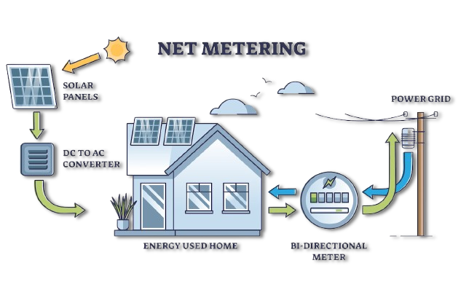

**Basic components for grid connected system**

* + - * + **Solar PV module**
        + **DC cable**
        + **Structures**
        + **Inverter/PCU**
        + **Earthing & Lightening Arrestor**

**Protection**

* DC side modules will be given DCDB for protection and to avoid any short circuit.
* AC side will be given ACDB as a protection on AC side So every care has been taken from our side so as to protect the system and give more life to system

**Advantages**

* Save electricity by using free source of solar energy
* One time investment and you can use free electricity for 25 years or more.
* Long life system
* Low maintenance

**Scope of Work**

* Design, Engineering, Supply, Installation & Commissioning of Solar PV Power Plant
* Detailed planning for smooth execution of project
* Performance testing of the complete system

**Service after Sale**

After sale service warranty will be 1 year for cables, inverters, etc.

Service warranty includes:

* Monitoring of system through the day, analysing daily and monthly generation & reconciling it with electricity bills, publishing quarterly and yearly report on gross and net savings, tracking service issues till they are resolved, identifying their root causes, maintaining configuration records, quarterly system audit, etc.
* Besides these, a managed service also covers activities such as loose connections, grid islanding check, firmware upgrades, etc.

**TERMS AND CONDITIONS**

|  |  |  |  |
| --- | --- | --- | --- |
| **Local Tax, CST/VAT, Octroi,** | Any changes in tax at the time | | |
| **Duties, Service Tax** | Of execution shall be at extra cost to customer account. | | |
| **Freight & Insurance** | Transportation is included. | | |
|  |  | | |
| **Project Implementation schedule** | 60 business working days from the date of receipt of payment | | |
|  | commercially clear order (with all engineering approvals) with  advance and payment schedule accepted by CE | | |
| **Payment Terms** |  | 40% advance along with confirmed PO | |
|  |  | 40% against first material delivery | |
|  |  | 20% after installation of solar panel on structure  Payment should be done as per terms without any delay | |
| **Supplier’s Scope of Work** |  | Complete with Design, Supply, Installation, Testing of system | |
|  |  |  | |
| **Buyer’s Scope of Work** |  | Site preparation work will be in customer’s scope, which | |
|  |  | includes readiness of site for installation of Mounting | |
|  |  | structure, erecting of Mounting structure and PV Array and | |
|  |  | any other site related work and activities, internet facility for RMS system should be provided | |
| **System Warranty:-** |  | 1 year free service warranty | |
|  |  |  | |
|  |  |  | |
|  |  | **Product Warranty:-** |  |
|  |  | Module: Performance warranty for 25 Years from the | |
|  |  | Manufacturer. | |
|  |  | 60-84 Months warranty of Inverter from date of installation from manufacturer. | |
| **Validity of Quotation** |  | 20 days from the date of quotation | |
| **Force Majeure Clause** |  | Force majeure clause applicable on the above offer | |
|  |  | All disputes (if any) are subject to Mumbai jurisdiction | |

We trust our offer would be in line with your requirements and looking forward to your valuable order and continuous relationship. In case of any further information or clarification, please feel free to contact us.

Thanking you and assuring you of our best services at all times.

Yours truly,



Thank You for Choosing Soryouth

**OUR Clients:**

Jatin Industries

